Quick Setup Guide

Table of Contents
Java 1
SVN and Tortoise Shell 2
Database Configuration 4
Verify the Informix driver is installed 4
Establish an ODBC data source for the Informix Database 7
Establish a JDBC data source for the Informix Database 10
Establish an ODBC data source for the Microsoft Access Database 10
Select either Informix or Access as your database 13

Java
Your computer must have the Java Runtime Environment Version 1.5 installed. Versions higher or lower will NOT work. If you do not have any version installed, one can be obtained by clicking the following link: http://www.java.com/en/download/windows_xpi.jsp. If you already have a version of the Java Runtime Environment, proceed with the following directions for checking the version number.

In Microsoft Windows
- Navigate to the Control Panel.
- Double-click on Java.
- In the Java Control Panel:
  - Click the About… button.
  - Check to see if the version is 1.5 or higher.
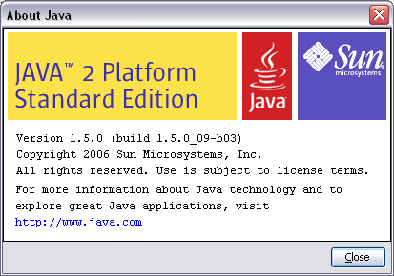
  - Close the About Java window.
  - If the version is lower than 1.5:
    - Select the Update tab.
    - Click the Update Now button.

SVN and Tortoise Shell
Subversion (SVN) is a version control system that allows you to have the most up-to-date version of the files and programs associated with DSM2. Tortoise Shell is an interface for SVN that is integrated into Windows Explorer.

The latest files and programs for DSM2 will now be in a repository at \\delta-mod\Share\Studies\DSM2. After installing DSM2, SVN, and Tortoise Shell, special icons will show up in Windows Explorer telling you whether you have the latest version. A small green check mark indicates that your file is up-to-date. A small red exclamation point indicates that your file is out-of-date. If your version is outdated, simply right-click a file or directory, and select SVN Update.

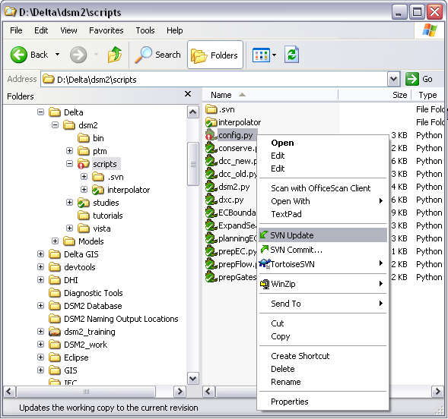
The following directions are for installation:
- Click on the following link: \\delta-mod\YDrive\SoftwareUpdates\SVN.
  - To install SVN, double-click:
svn-1.4.0-setup.exe.
  - To install Tortoise Shell, double-click:
TortoiseSVN-1.4.0.7501-win32-svn-1.4.0.msi.

Database Configuration
DSM2 Version 7 stores simulation data in a database. You can choose between using Informix, a network database; and Microsoft Access, a personal database. Preferably, DWR employees would use the Informix database, with all layer information being shared. The Microsoft Access database would be used for non-DWR employees, and for DWR employees who wish to preserve the database as it was at the time of their model run.

Scripts are provided that allow DWR users to make a Microsoft Access copy of the Informix database (covered in the section, Copying Informix to Microsoft Access). The users can then archive their personal database file in a folder of their choosing. At any time, the GUI can be configured to connect to this preserved database.

You must have an Informix account to gain access to the Informix database. If you do not have an Informix account, you can email Mike Mullen of Computer Assistance at mmullen@water.ca.gov, and he will send you a password.

For the use of either database, drivers must be installed, and connections must be established. Informix makes use of both an Open Database Connectivity (ODBC) and a Java Database Connectivity (JDBC). Microsoft Access makes use of only an ODBC connection.

Verify the Informix driver is installed
In Microsoft Windows
- Navigate to the Control Panel.
- Double-click on Administrative Tools.
- Double-click on Data Sources (ODBC).
- Select the Drivers tab.
- Check if the IBM INFORMIX ODBC DRIVER (version 2.9 or higher) is on the list.
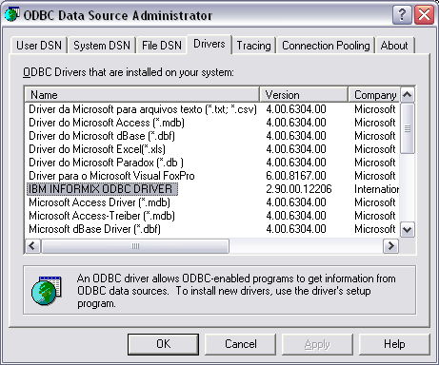

- If the driver is installed, skip to the following section on establishing the ODBC connection. If the driver is missing, continue with the following directions:
- Click the following link: \\delta-mod\YDrive\SoftwareUpdates\Informix.
- Double-click the file: clientsdk.2.90.TC1.zip.
- Extract the contents to a temporary folder, and navigate to that folder.
- Double-click the file: IBM Informix Client-SDK.msi.
- In the setup window:
  - Click Next >.
  - Accept the license agreement and click Next >.
  - Enter any User Name and Organization, and click Next >.
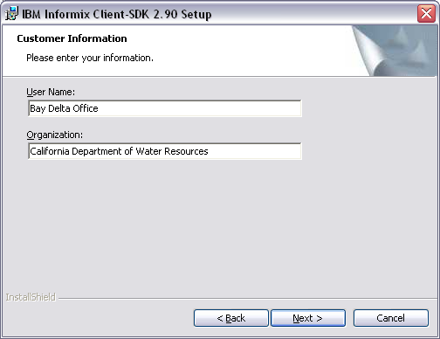
  - Select a Custom setup and click Next >.
  - Accept the default directory and click Next >.
  - Deselect everything but the IBM Informix ODBC Driver by left-clicking the other items and selecting the red x. Then click Next >.
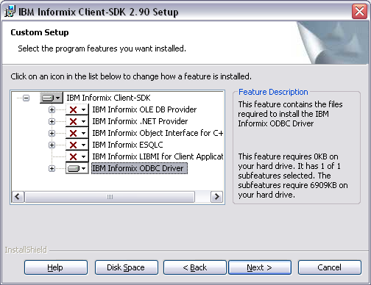
  - Click Install.
  - Click Finish.

Establish an ODBC data source for the Informix Database
In Microsoft Windows
- Navigate to the Control Panel.
- Double-click on Administrative Tools.
- Double-click on Data Sources (ODBC).
- Select the System DSN tab and click Add….
- Select the IBM INFORMIX ODBC DRIVER and click Finish.
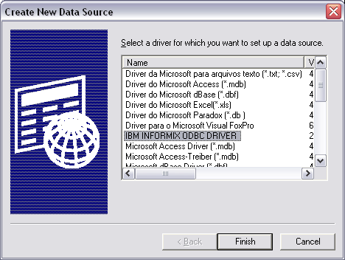
- Under the General tab, enter dsm2input for the Data Source Name, and provide a description.
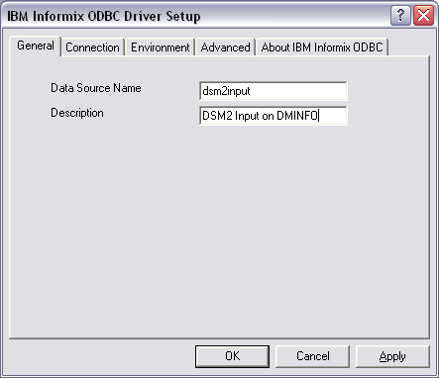
- Under the Connection tab, enter the following information:
  - Server Name: ius_dminfo_tcp
  - Host Name: 136.200.32.24
  - Service: 1538
  - Protocol: olsoctcp
  - Database Name: dsm2input
  - User Id: use your username
  - Password: enter the password provided by Computer Assistance (Mike Mullen).
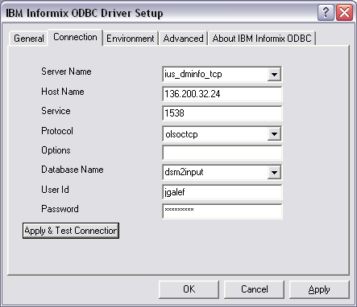
  - Click the Apply & Test Connection button.
  - If connection was successful, click OK.
  - Click OK to accept the degradation message. 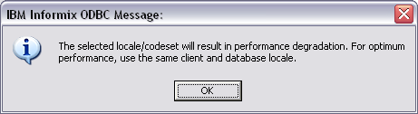

Establish a JDBC data source for the Informix Database
In the GUI
- Click on the Tools menu.
- Select Configure Database.
- For the JDBC URL, copy and paste the following :
jdbc:informix-sqli://136.200.32.24:1538/dsm2input:informixserver=ius_dminfo_tcp
- For the JDBC driver, copy and paste the following:
com.informix.jdbc.IfxDriver
- Enter your username and Informix password. 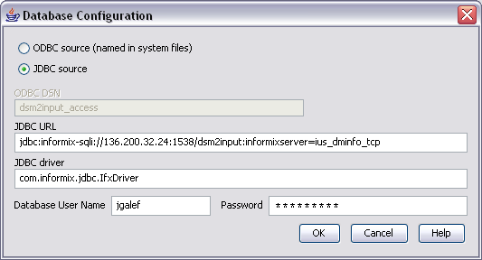

Establish an ODBC data source for the Microsoft Access Database
In Microsoft Windows
- Navigate to the Control Panel.
- Double-click on Administrative Tools.
- Double-click on Data Sources (ODBC).
- Select the System DSN tab and click Add….
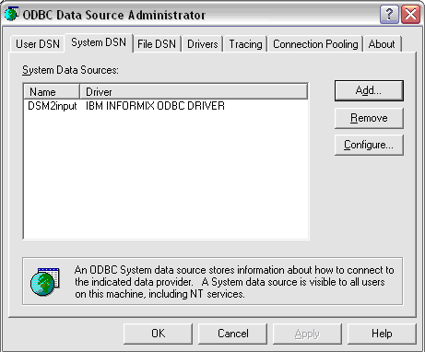

- Select the Microsoft Access Driver (*.mdb) and click Finish.
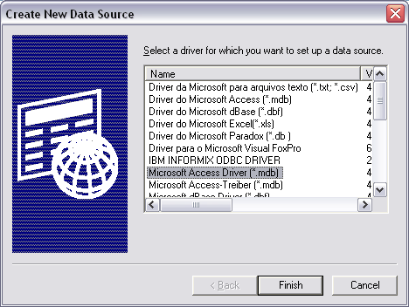
- In the ODBC Microsoft Access Setup Window:
  - For the Data Source Name, type dsm2input_access. 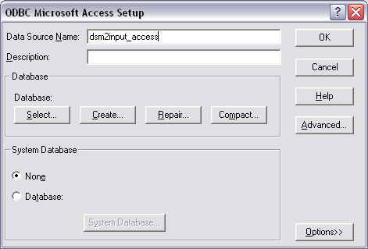
  - In the Database section, click on Select…
  - In the Select Database window:
    - Under the Drives section, select the drive letter where the tutorial is stored.
    - In this document, the directory where you installed DSM2 will be referred to as {DSM2_home}. E.g., if you accepted the default install directory, {DSM2_home} would be d:\delta\dsm2.
    - Under the Directories section, navigate to {DSM2_home}\dbase.
    - Under the Database Name section, select DSM2input.mdb.
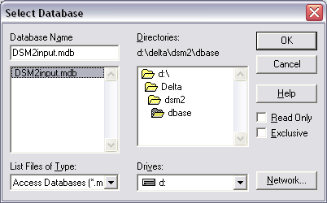
    - Click OK.
  - In the ODBC Microsoft Access Setup Window, click OK.

Select either Informix or Access as your database
In the GUI
- Click on the Tools menu.
- Select Configure Database.
- Here is where you select which database to use.
- For Informix:
  - Select JDBC Source.
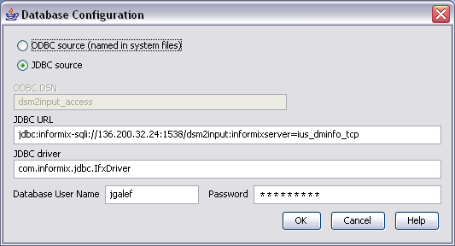
  - Make certain the proper information is given in the JDBC URL and JDBC driver input boxes. (See previous section if necessary)
- For Microsoft Access:
  - Select ODBC source (named in system files).
  - Fill-in the name of the personal database file in the ODBC DSN box.
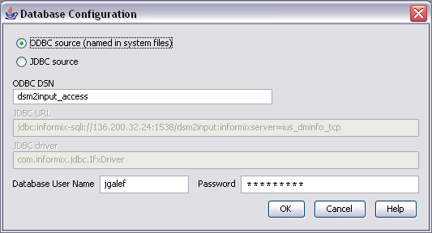
This must match the name given in the Data Sources (ODBC) window of the Administrative Tools of the Control Panel.
